Shabbos Stories For
Parshas chaya sara 5786
Volume 17, Issue 9 24 Cheshvan November 15, 2025
Printed L’illuy nishmas Nechama bas R’ Noach, a”h
For a free subscription, please forward your request to keren18@juno.com
Past emails can be found on the website – ShabbosStories.com

The Eliyahu Hanavi Test
By Yehuda Z. Klitnick

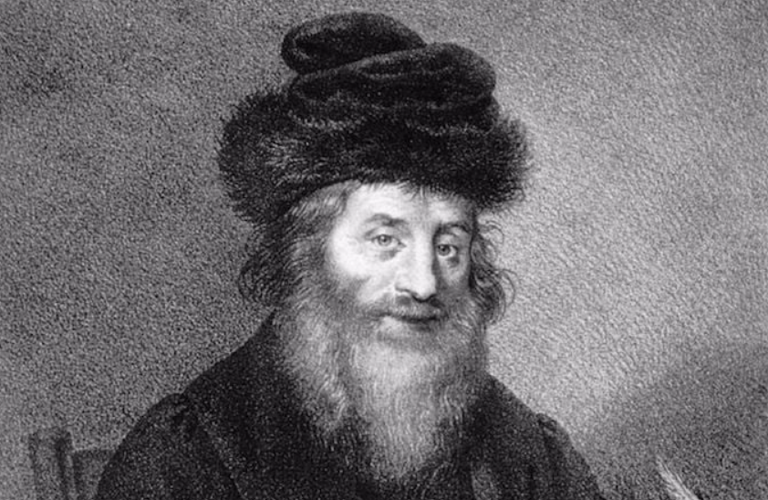
Original lithography of the Chatam Sofer (Rabbi Moshe Schreiber-Sofer) by Josef Kriehuber, circa 1830;

The great gaon Rabbi Yehuda Modern (1819 – 1893), sat bent over a Gemara. He was a student of the Chasam Sofer. Rabbi Yehuda was a genius, and by eight years old he was accepted into the yeshiva, and at 12 years old, he received his Semicha. He married and settled in the city of Siget, and became close the heilige to the Yismach Moshe. His Seforim are "Zichron Shmuel" and "Pri Ha'etz". [Yet,] he never received a Rabbinical position!
One summer day a sharp knock on the door interrupted Reb Yehuda’s learning. He opened the door, and he encountered a puzzling sight. At the door stood a man, his eyes were familiar to him, the face of a Jew, but his clothing that of the nobles of the Gentiles. His familiar eyes somehow prevented Reb Yehuda from slamming the door in his face.
He recognized a familiar look, that took him back many years. "Shamshon... is that you!?"
The man nodded, "Indeed, Reb Yehuda. It's me."
Reb Yehuda's soul traveled back in time, he remembered Shamshon, the "super genius" of the yeshiva, whose entire future was destined for greatness, with tremendous talents! What happened to a boy who was created for greatness?
Reb Yehuda's mind meditated, and in an instant, remembered an act that had happened, that was the key to this mystery. The conversation among the bochurim in Pressburg was about the level of the Chasam Sofer, as it was known that the Rov met periodically with Eliyahu Hanavi.
The students hoped they too will merit this. Those who were close to the Rov, went to ask for a bracha to see Eliyahu Hanavi! The Rov promised that he will attempt to satisfy them, and that they be ready! One day, while everyone were absorbed in learning, a poor man entered the Beis Midrash, dressed in worn-out rags, his back bent and his face furrowed with wrinkles.
He sat down in a corner, neglected. Most of the students were not even aware of what was happening around them, they did not even notice the entry of the stranger dressed in tatters. There were also those who glanced at him and immediately returned to their Talmud, and there were even those, including Shamshon, who mocked at his repulsive appearance. Only a few students, got up from their seats, approached the poor man, and shook his hand warmly with the greeting "Shalom Aleichem".
Suddenly, the Chasam Sofer entered, his eyes scanned the large hall sharply, and without waiting, he went directly to that poor man, took him by the hand and said to him, "Shalom Aleichem, my Rebbe!" He led the guest with all the honors into his room, where they remained together for a while.
When the Chasam Sofer came out, his face flushed, he gathered his students around him and asked: "Which of you gave "Shalom Aleichem" to that poor man?" He was none other than Eliyahu Hanavi! Those who stood up and bestowed upon him honor, will be granted the privilege of teaching Torah and become Rabbanim! Those who ignored him, even though they were worthy in terms of their Torah, they will be withheld from a Rabbinical throne," and he continued in a unhesitating voice, "That small handful who who laughed at his appearance, those will fall from the straight path !"
Now Reb Yehuda began to understood everything. He looked at his old friend, and saw before him the fulfillment of their Rabbi's holy words as Shamshon was the instigators of the mockers!
"And now, Shamshon, where are you headed?"
Reb Yehuda asked. "I heard of Rabbi Meir from Premishlan," Shamshon replied, "They say that he sees all of a person's actions. I am going to him to see if the truth is true. I have had my fill of the world's pleasures, my eyes have already seen everything... I have heard that Rabbi Meir sees in a person's soul all of his sins, my soul longs to see closely if the truth is true."
Reb Yehuda saw in his words a spark of remorse, a first reflection on repentance. "Shamshon," he said to him firmly, "I ask you one thing. Promise when you return from Premishlan, you will come back to me again, to tell me what you have seen."
Shamshon agreed. Several weeks passed. There was another knock on Rabbi
Yehuda's door. Shamshon stood at the door again, but it was not the same man. His clothing was still foreign, but his posture was more stooped, his arrogance had subsided, his speech was moderate, and everything was filled with remorse.
With a sharp eye, Rabbi Yehuda noticed that this time, upon entering his house, Shamshon lowered his eyes, and with reverence for the holy place he kissed the mezuzah... Reb Yehuda did not need to ask anything. He understood for himself that the visit to the righteous man from Premishlan was the beginning of the ember of repentance that had already begun to whisper. Shamshon indeed returned to his roots in zchus of Reb Meiril.
Rabbi Yehuda testified about himself that he himself was one of the young men whose strength was strong in Torah, they did not bother to greet the man dressed in tatters who entered the yeshiva hall, Reb Yehuda noticed his entry, but his perseverance in Torah prevented him from getting up and giving Shalom to the guest. Hence, he never was able to receive a Rabbinical post. But he was a tremendous Torah Scholar.
When someone obscure enters a Shul, it might be Eliyahu Hanavi, and Blessed is the one who has given him peace, and restore peace to him, Hashem will bless His people in peace.

Reprinted from the Parshas Lech Lecha 5786 email of Pardes Yehuda.

Offering the Rav a
Ride to Anywhere

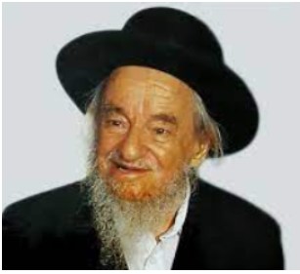
Rav Yankel Galinsky

One day Rav Yankel Galinsky was walking on the street in Bnei Brak. A car stopped, the window rolled down and the driver asked, "where does the Rabbi need to get to?"
"What's the difference," asked Rav Galinsky?
"Wherever the Rav needs I will drive the Rav."
Rav Galinsky entered the car, turned to the driver and asked, "tell me, you'll really take me wherever I need?"
"Yes, wherever the Rav wants."
"I am heading to Yerushalaim."
"No problem." And the driver started heading out to Yerushalaim. Rav Galinsky said to the driver, "I have two requests. One please can you stop by the bus stop to Yerushalaim."
"No way, I have the Mitzvah and am taking you all the way to Yerushalaim," cut in the driver.
"Second, please can you explain why you are willing to drive me anywhere?"
"My pleasure, for that I have the next hour till we get to Yerushalaim."
The driver told over the following story. As a child I went through a very rough childhood. My father was very tough and we had a lot of clashes. Life was bitter at home. One day I heard by chance that there is a Government hostel for homeless and abused kids near Zefas. I was sure that the kids there were just like me. I decided to leave home and go to start a new life in the home. But deciding was easy, doing it was a different story.
“But one night I had a big fight with my father and I walked out, slammed the door and left without anything, not even my Tefillin. I had a bit of money in my pocket so I took the bus 450 from Jerusalem central station till Tel Aviv train station. I checked when the next train to Zefas was and I had an hour and a half wait. I couldn't sit for that long waiting,
“I was too worked up and very hungry. I walked out the station to the nearby streets. There I saw a Shul with a sign outside that they were having a "Yom shekulo Torah" - a day of Torah study, something very popular on bank holidays etc. I remembered going to one with my father a few years back and remembered that there was cake and drinks there too. So, I walked inside just as a Shiur finished and joined everyone to have some cake, borekas and drinks. But I still had another hour till the train so I decided to sit and listen to the next Shiur.
“The next Shiur was given by you Rav Galinsky. And I remember what you said. You told over a question from the Ponevaz Rav. The Mishna in Pirkei Avos (5-14) says that there are four different people who go to the Beis Hamedrash to study. There is the person who goes but doesn't understand what he learned but he actually went to Shul. This person is rewarded for going to Shul.
“Then there is the person who doesn't go but learns, he learns at home. He is rewarded for his studies. Then there is the person who goes and studies in Shul, he is a Chassid - a righteous person. Finally, there is the person who doesn't go to Shul and doesn't learn at all, he is a Rasha - a wicked person.
“The Ponevaz Rav asked if the person doesn't go to Shul and doesn't learn at all why is he mentioned as one of the four going to the Beis Hamedrash? He has no connection at all. The Ponevaz Rav gave an answer with an important message. The person who goes to Shul and studies Torah has the great spiritual pleasure and elevation from his studies. But the person who goes to Shul and doesn't understand his studies doesn't enjoy his time in Shul and doesn't get pleasure, that person begins to consider whether he should continue coming to Shul, after all what is the point. He sees other people sitting and studying and having such enjoyment but how can he enjoy his studies if he doesn't understand.
“There is the person who comes to Shiur after a long day’s work completely exhausted and try as he may but he is too tired to concentrate and appreciate the brilliance of the daily Shiur. So, he also begins to reconsider if I'm so tired I may as well just go to sleep. But then he looks at the people who don't come to Shul to study at all, they don’t even study on their own at home either and sees what kind of life a Jew looks like without any Torah and realizes that although now he doesn't understand the Gemara but if he continues with diligence Hashem will open his mind to understand. He understands that maybe now he's too tired to concentrate but there will be days in the future that he will be able to be fresh and alert during the Shiur.
“So these people don't give up, they continue coming to the Beis Hamedrash. But who helped them? Those that don't come and don't learn at all. They are the cause that others should go to the Beis Hamedrash. So, they are also players in those that go to Shul to study. Their lifestyle caused others to go to the Beis Hamedrash. So, the Tanna mentions them as well.
The driver continued and said I realized that I fitted just into your lecture. Here I was come from an observant home with difficulties trying to run away and give up. True life was tough at home and I wasn't getting along with my parents to put it mild, but I had a future. I was nearly finished with Yeshiva Ketaneh ready to go to Yeshiva Gedolah, then get married and set up a nice Jewish home. Instead I was running away to a hostel of non-religious kids that could ruin my future life.
“Then you carried on and mentioned about how Hagar ran away from the house of Avraham Avinu because Sarah Imeinu made her life bitter. The Malaachim asked her where are you running away from and where are you going to? Hagar answered I am running away from Sarah my boss. The Malaach replied go back and suffer. Why didn't Hagar explain what suffering she was enduring?
“The answer lies in the words of the Malaach. Yes you may be suffering but where are you running away from? From the home of Avraham the Tzaddik. Where are you going to end up with in the desert? Better go back to the home of Avraham Avinu and suffer there but at least you're in an environment of Torah and Emuna. And I realized, said the driver that your whole lecture was applicable to me. So, I went home and it wasn't easy but Baruch Hashem I went through Yeshiva, got married, have a nice family, set up a good and successful business, and Baruch Hashem things are all OK. But my whole life was saved by those moments that you happened to be the speaker in a Shul that I happened to enter for some food.”
We have been through the month of Tishrei, we had Rosh Hashanah Yom Kippur, Succos, Simchas Torah, a month that hopefully left us with spiritual energy for the new year. Our aim is to carry on through the year and live in our homes a life of Torah, Chessed, Emuna and good Middos. A life that shines happiness and spiritual growth to our children and our family that every Malaach looks at our home and says who would want to leave such a special home?!

Reprinted from the Parshas Lech Lecha 5786 email of Inspired by a Story by Rabbi Dovid Caro.

Saved by the Nanny,
Adopted by the Rebbe
As told by Mrs. Miriam Fellig

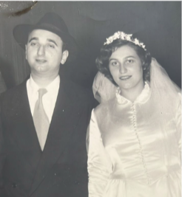
Joe (Yosef Mordechai) and Miriam Fellig at their wedding in May 1950.

Before the war, life in Warsaw was beautiful. My father was a chemist who did quite well financially, and although they were not very religious, my mother had come from a religious family, and she kept the house kosher. But then Hitler came, and everything changed.
After we moved into the ghetto, my father got in touch with my gentile nanny and sent me to her. She was like a second mother to me, and I stayed with her until the war was over, which was when I found out that my family had not survived. Barely a teenager, I didn’t want to leave my nanny, but she insisted: “You have your own people to go to.”
There were various Jewish organizations taking care of orphans, and they sent me around to different orphanages, a couple of which were run by Lubavitch. These organizations tried to find out if I had any relatives in other countries who could take me in, but I didn’t have any.

Meeting Her Future Husband Who
Was Originally from Vienna
Eventually, a couple of years after the war, the Canadian Jewish Congress wanted to bring in a group of 500 orphans, and I ended up being one of those youngsters. We arrived in the port of Halifax on a big boat, before being sent to Montreal. It was there, at the age of sixteen, that I met my husband. He was originally from Vienna, but had already been living in Montreal for a few years, after being taken in and then hired as a teacher by the Lubavitcher yeshivah there.
He had an old car, and every day he would come to visit me. He must have liked me and, in May 1950, when I was eighteen, we got married. I was nervous about it, and had absolutely no money, but our wedding was still very nice, and my husband made me feel safe and secure.
In 1951, my husband decided that we would go with our son, Yanky, to New York for the holiday of Simchat Torah, in order to see the [Lubavitcher] Rebbe for the first time. This was the year that the Rebbe had succeeded his father-in-law and assumed the position, but I had already heard so much about him and was curious to meet him.
We drove to New York, and in 770, we came into a hall where there were a lot of people sitting and waiting for a chance to see the Rebbe. The Rebbe’s secretary told us that it would be a long wait, and everybody seemed to get more nervous and more excited as time went on; some people were crying, some were laughing, and others were reciting Psalms.
Eventually, the secretary opened the door, and we went into the Rebbe’s office. I looked at the Rebbe’s beautiful eyes, and I felt relaxed. He had a kind smile, and there was a very pleasant atmosphere in the room. “Is there anything you want to say?” asked the Rebbe.
“Yes, Rebbe,” I said, and I told him how we had gotten married, had a baby, and now I was expecting my second child. “I would like to have a lot of children and raise them well!” Hitler had taken everything away from me, but I resolved to restore what was lost by having many children, who would want to have children of their own.
“But,” I continued, “I’m afraid that I won’t be able to manage. I have no family, so I’m afraid that I won’t know what to do or have anyone to ask for advice.”
“No one?” asked the Rebbe. “Just my husband, and no one else. I would like it very much if the Rebbe could adopt me. Then I wouldn’t feel alone anymore.” It was an unusual question, but it was what I needed.
“Alright,” said the Rebbe. He took a little black book out of his pocket and wrote down the names for me, my husband, and Yanky. We agreed that when I had more children, I would send their names to the Rebbe, so that he could add them to his book. Then the Rebbe told me to always be happy, that everything would be fine, and that he would see me next year.
Going through the Holocaust had caused me a lot of unhappiness, but in that moment, I felt very happy. I thanked the Rebbe a million times, and off we went. We came back the next year, and by then we had another baby — Hershy. The Rebbe asked about the children and about me, and I mentioned that I had been taking some medication for a stomach problem. The Rebbe understood what the issue was and had a suggestion: “Don’t use the medication – you can drink Saratoga water instead.” He was talking about the special mineral water of Saratoga Springs, New York; they sell it everywhere now. So, on the way back to Montreal, we stopped off there and got some of the water.
At one point during that meeting, Rabbi Leibel Groner, one of the Rebbe’s secretaries, began knocking on the door to bring the audience to a close. “Please, Rebbe,” I begged, “I don’t want to go yet. Tell him to leave us alone.”
Hearing that, the Rebbe told Rabbi Groner that the next person in line would wait until I came out.
Generally speaking, we would come back every year for Simchat Torah, putting all of the kids into our station wagon and driving to New York. But before long, with no family in New York and so many kids, finding a place to stay became impossible; most people couldn’t handle so many guests!
So, one year, I brought it up with the Rebbe. “It feels like everybody’s house is full with their own family,” I complained. “We would love to continue coming every year, but we have no place to stay.” “Don’t worry,” the Rebbe reassured me, “You will have a place.”
When we came back the next year, Rabbi Binyomin Klein, another one of the Rebbe’s secretaries and a very nice man, brought us a set of keys. They were for an apartment just behind 770 that was recently purchased by the Rebbe’s office. Later, that building housed a kollel for young married men to study Torah, but at that point, it was going unused. “Here are the keys,” he said. “When you are finished, bring them back.”
I couldn’t believe it. We brought some beds to sleep on, and every year, that was where we would stay. I felt that being with the Rebbe in New York for the holidays each year gave me the strength to take care of my kids the rest of the year.
One time, when I confided in the Rebbe about some of my fears and concerns — I was always worried about everything — he told me, “Don’t be a worrier, be a warrior!”
I felt very close to the Rebbe, as if he was my only friend. He understood me and always gave good, compassionate advice. He understood that we needed him, that we believed in him, and trusted that whatever he said was right — and somehow, it always was. He was someone I could count on, and he never disappointed me.
______________
After surviving the Holocaust, Mrs. Miriaim Fellig, together with her husband Joe, went on to have ten children, and many more grandchildren and great-grandchildren. She was interviewed in January 2009 and passed away in November 2021 at the age of 89.

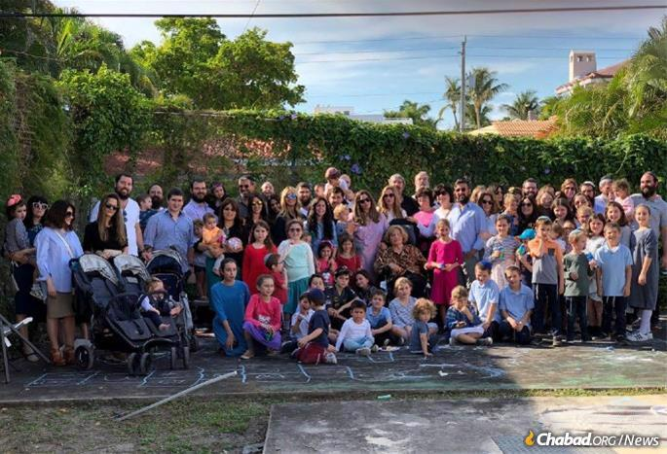
Miriam Fellig surrounded by her children, grandchildren and great-grandchildren. A great-great-grandchild was born shortly before her passing. Her family, she would say, was her victory over the Nazis.

Reprinted from the Parshat Lech Lecha 5786 edition of Here’s my Story, My Encounter with the [Lubavitcher Rebbe,] an oral history project of JEM (the Jewish Educational Media.]
Getting Sick in a Strange American City

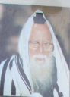
R’ Moshe Pardo, zt”l

The Ohr Hachaim neighborhood was established in 5745/1985, by noted educator and master of chessed R’ Moshe Pardo zt”l, founder of the Ohr Hachaim network of yeshivos and many other educational institutions in Bnei Brak. R’ Moshe often traveled the world to raise funds for his institution’s massive budget.
One such trip took him to a remote American city devoid of Torah-observant Jews, where a meeting had been arranged months in advance with a wealthy philanthropist. As the meeting approached, R’ Moshe suddenly came down with a fever and felt very ill.
Though he was determined to proceed, his attendant noticed the severity of his condition and insisted that he lie down and cancel the meeting. R’ Moshe reluctantly agreed, wondering why Hashem had brought him all this way just to lie in bed. But his deep bitachon quickly reminded him: “This is not a coincidence. Hashem has a reason.”
The meeting with the wealthy philanthropist was called off. That night, a local doctor was called in to examine him. As R’ Moshe removed his long rabbinic jacket, the doctor noticed his tzitzis and exclaimed, “People still wear these? I thought they were long forgotten.”
R’ Moshe, with his heavy Hebrew accent, replied, “Doctor, come to Israel and you’ll see hundreds of thousands of people wearing tzitzis. Even here in America, there are hundreds of thousands, even millions. I run a school with over 1,000 female students whose dream is to marry men who wear tzitzis. Many come from homes where their fathers didn’t wear them, yet now it is their greatest aspiration.”
R’ Moshe invited the doctor to visit his school if he ever came to Israel and the doctor said he would take it into consideration. After the exam, the doctor gave his diagnosis and wrote a prescription. R’ Moshe tried to pay, but the doctor refused. Still determined, R’ Moshe placed money on the desk along with a pair of Tefillin he carried for moments like this - for Jews who were open to reconnecting.
He always took an extra pair of Tefillin on his journeys just in case he came across a person like the good doctor - a well-meaning Jew who doesn’t know much and is ready to strap them on once he’s informed about it. He pulled out the Tefillin from their bag, showed the doctor the straps, and assisted in placing them on his hand and head.
The doctor was thrilled to put them on and he even recited a few prayers that R’ Moshe helped him say. Though the original meeting couldn’t be rescheduled, R’ Moshe left the city with a sense of comfort: a fellow Jew had put on Tefillin because of his visit.
Months later, R’ Moshe’s office phone rang. “I’d like to check out your institution,” said the voice on the other line. “I’ll be there in thirty minutes.”
R’ Moshe had no idea who the person on the other end was, but if he insisted, R’ Moshe wasn’t going to deny him the opportunity. Half an hour later, an extravagant vehicle pulled up, a chauffeur jumped out, opened the back door, and who stepped out? The doctor who had treated R’ Moshe in that isolated city in America.
R’ Moshe greeted him warmly, thanked him again for helping him out when he needed him, and they proceeded to tour the school. The doctor was visibly moved, showing the same emotion and thirst for Yiddishkeit he had shown during their first meeting months earlier. After the tour, he asked to speak to R’ Moshe privately.
“I thought your school had maybe 100 students,” the doctor admitted. “But now I see the empire you’ve built.” Then, with deep emotion, he continued. “I’ve been childless all my life with no close inheritors. I’m going to leave all my possessions to your school - my considerable life’s savings. I’ll contact my lawyer to finalize the will. You will be the beneficiary.”
R’ Moshe almost swooned when he heard the doctor’s words. In a voice charged with great emotion, he responded, “My friend, do you realize the power of what you’ve done? The Mishnah teaches that money doesn’t accompany a person to the World to Come. But now, you’ve transformed the material into eternity. What a deal!”
Reflecting on the experience, R’ Moshe said, “At first, I thought I was sent there just to help a Yid put on Tefillin. Now I see it brought in the greatest endowment the school has ever received - more than tenfold what I expected from the canceled meeting.”
Hashem had turned what seemed like a failure into the greatest success. (Reprinted from Rabbi Moshe Hirschberg’s Zichru Toras Moshe – Shabbos Table Stories)

Reprinted from the Parshas Lech Lecha 5786 edition of Torah Tavlin.

An Important Lesson for a Future Chief Rabbi
By R’ Yoni Schwartz

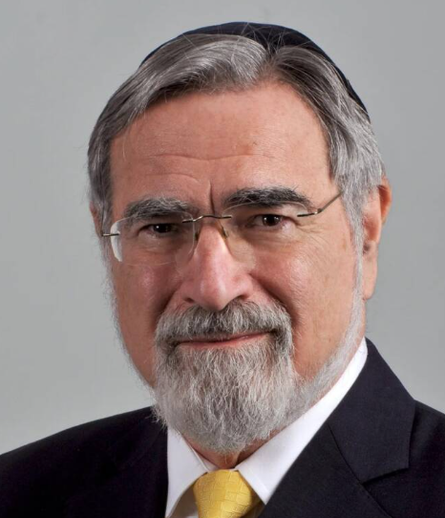

In his incredible book “Radical Then Radical Now” Rabbi Jonathan Sacks [of blessed memory and former Chief Rabbi of the United Kingdom] explained that sometimes seemingly insignificant experiences can have big impacts on our self-perception. He retold the following well-known story that Sigmund Freud wrote in one of his books: “When Freud was a young boy, he was holding his father’s hand. His father looked at him and said, ‘Things are so much better now than they were in my day. Once somebody came, took my Kippah, threw it in the mud, and screamed, ‘Get off the pavement, Jew!
‘What did you do?’ asked little Sigmund. His father replied, “I picked it up, wiped it off, and continued on my way.” This struck little Sigmund as a cowardly and unheroic act which, as Rabbi Sacks proposed, set him up for a life of ambivalence towards his own Jewish identity
The Rav then explained that he once had a similar but opposite experience. When he was a young boy, the terrible British saying, “Be a Jew at home and a man in the streets,” was still being used.
One time, as he was leaving shul with his father, a well-meaning congregant approached him and said, “Oh, Mr. Sacks, I’m afraid it looks like your son had forgotten to take off his yarmulke.”
This person was only trying to “save him from embarrassment.” However, Rabbi Sacks’ father got angry and told that man in a forceful tone, “No son of mine will be ashamed to be a Jew!” He then took his hand, said, “Let’s go, son,” and marched away with a huff.
Rabbi Sacks explained how this moment shaped him and allowed him to undertake years of learning philosophy and hearing people try to prove G-d doesn’t exist without the slightest doubt of his own faith’s validity, all the while wearing a kippah proudly on his head.
Reprinted from the Parshas Lech Lecha 5786 email of Torah Sweets.
The Broken Shiduch
By C.B. Weinfeld

Chana* had just come back from seminary — that magical, transformative year in Eretz Yisroel that so many girls dream of. But now that it was over, the big question loomed: what next? She wanted to do something productive and practical, something she’d actually enjoy. Since she’d always had a head for numbers, Chana decided to enroll in an advanced accounting training course and intern a few hours a week at a small accounting firm. It wasn’t exactly exciting, but it was sensible — and practicality mattered.
Still, the shift from a year steeped in ruchniyus, with daily shiurim and uplifting role models, to long hours of ledgers and spreadsheets was jarring. Her days were packed with work and study, leaving barely a moment to breathe. Once a week she made sure to do some chessed — visiting an elderly woman at the nursing home or helping a neighbor who had just had twins — small gestures that added meaning to her otherwise colorless routine.
Yet she missed seminary — the friends, the inspiration, the sense of purpose. Accounting made sense for parnassah, and she wasn’t the “teaching” type, but she couldn’t help wondering, Is this really it? Meanwhile, shidduchim were beginning to enter the picture. Her parents lived simply and could only offer a year of support, so Chana knew she had to be realistic.
Then came a surprise suggestion — Shlomo Rosman*. Shlomo’s aunt in Yerushalayim had heard glowing things about Chana from her neighbor — the very woman Chana had gone to weekly for her chessed project! Impressed, the aunt told Shlomo’s mother, “You should put this girl at the top of your list.”
And so, Chana and Shlomo met. To everyone’s pleasant surprise — especially Chana’s parents — they hit it off immediately. After the fourth date, there was that quiet excitement in the air — the feeling that this might really be it. And then, everything fell apart. It was a week before Chanukah, and they were supposed to meet Thursday night.
When Chana got home from her course, her mother’s uneasy expression said it all. “The shadchan called,” she said softly. “Shlomo can’t come tonight.” Chana shrugged. “No problem. Maybe something came up.” But her mother hesitated before adding, “Shlomo changed his mind. It seems like the shidduch is over.”
Just like that. No reason. No explanation. Chana sat in stunned silence. Everything had been going so well — what had happened? The next few weeks passed in a fog. Chana went through the motions — working, studying, helping where she could — but inside she felt hollow. When she finally completed her accounting course, she began wondering if she should change fields, though her parents gently discouraged it.
Then came the final blow: a mazel tov announcement in the community paper — Shlomo Rosman and Tzippy Lerman*. Tzippy — her good friend from high school. The words blurred as she read them again and again. For a moment she felt betrayed, as though Tzippy had stolen her chosson, but she quickly pushed the thought away. She knew Hashem ran the world; if Shlomo was meant for her, no one could have taken him.
Still, the pain was sharp. Tzippy’s family had yichus, money, and connections — things Chana’s modest background couldn’t match. Her parents could promise a year of support; Tzippy’s could promise ten. Forcing herself to go to the vort, Chana smiled politely, said mazel tov, and slipped out after ten excruciating minutes, closing that chapter for good.
The next few weeks were lonely and cold, both inside and out. With no job, no school, and no shidduch on the horizon, Chana searched for something — anything — to fill her time. That’s when she began volunteering for an organization helping children battling serious illness. They were desperate for girls to stay with the children overnight or keep them company in the hospital. Chana was available — and willing.
And so began a new phase in her life. She didn’t know it yet, but this detour was about to lead her to places — and people — she never could have imagined. (Reprinted from the Parshas Lech Lecha 5786 email of The Weekly Vort. Excerpted from the ArtScroll book - Another Handful of Stars)

TO BE CONTINUED NEXT WEEK

